CT 16th Anniversary Charter Party

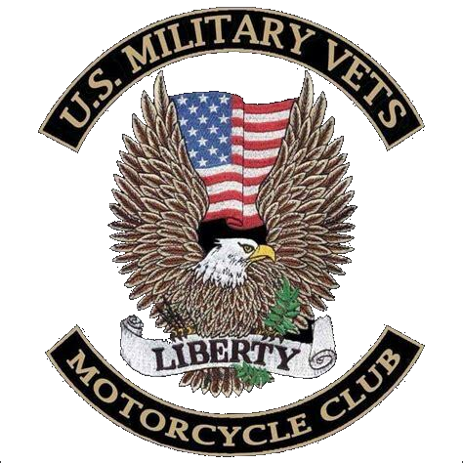

June 13th 2026
American Legion Post 14
114 West Street Vernon, CT 06066
Starts at 1300 Tickets $20.00
Cash Bar, Raffles, Food and Music
USMVMC reserves the right to refuse anyone

