**2026 MS State Mardi Gras Parade Annual and Brother Farmers Retirement Party**



**Saturday, Jan 31st, 2026. Parade starts at 1:00pm**

**The Juke Joint, 1911 Government Street, Ocean Springs, MS**

**Mardi Gras Parade, Brotherhood, Music**

**Drink Specials, Raffle & door prizes, great food !**

**Did we mention a live Mardi Gras Parade?**

**Meet & Greet Friday Night Jan 30th, 2026, at 7pm**

**The Juke Joint, 1911 Government Street, Ocean Springs, MS**

**The Juke Joint is located off I-10 exit 50, as are the Hotels.**

**The city shuts down Government Street at noon for the parade, so be sure you are in the Juke Joint parking lot prior to noon.**

**Come join us and help us celebrate 16 years of Brotherhood!**

**  **

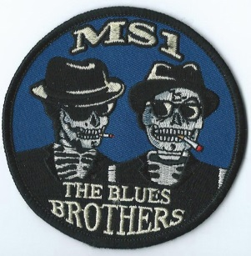

Hotel Info:

All the hotels are located at Mississippi I-10 Exit 50 in Ocean Springs, MS, and are convenient to everything.

**Ramada Limited**

**8011 Tucker Rd, Biloxi, MS 39532**

**Ocean Springs, MS, 39564**

**(228) 872-2323**

**Best Western**

**7921 Lamar Pool, Biloxi, MS 39532  
(228) 875-7111**

**Hampton Inn**

**13921 Big Ridge Rd, Biloxi, MS 39532  
(228) 872-6370**

**Holiday Inn Express & Suites**

**7301 Washington Ave, Ocean Springs, MS 39564**

**(228) 872-7255**

**If you have any questions, contact any Mississippi Brother!**

**Hope to see everybody there!**

**WE RESERVE THE RIGHT TO REFUSE ENTRY TO ANYONE FOR ANY REASON.**